Grainger Product Analytics Dashboard

Project Objective
In this project, I analyzed a 500-product dataset based on Grainger's catalog to uncover sales performance, inventory health, and historical trends from 2000 to 2024. The goal was to create a clean, interactive Power BI dashboard that helps stakeholders quickly understand revenue distribution, product ratings, stock risks, and time-based patterns.
Data Preparation
I started by cleaning and enriching the raw dataset in Google Colab. I added useful calculated columns such as:
- Revenue: Derived from PriceUSD * UnitsSold
- LowStock: Flagged items with StockQty < 20
- SalesLevel: Grouped based on Units Sold (Low / Medium / High)
- PriceRange: Bucketed product prices
- OrderDate: Random dates between 2000 and 2024
- OrderYear: Extracted for trend analysis
Once cleaned, I exported this file as grainger_with_random_order_dates.csv.
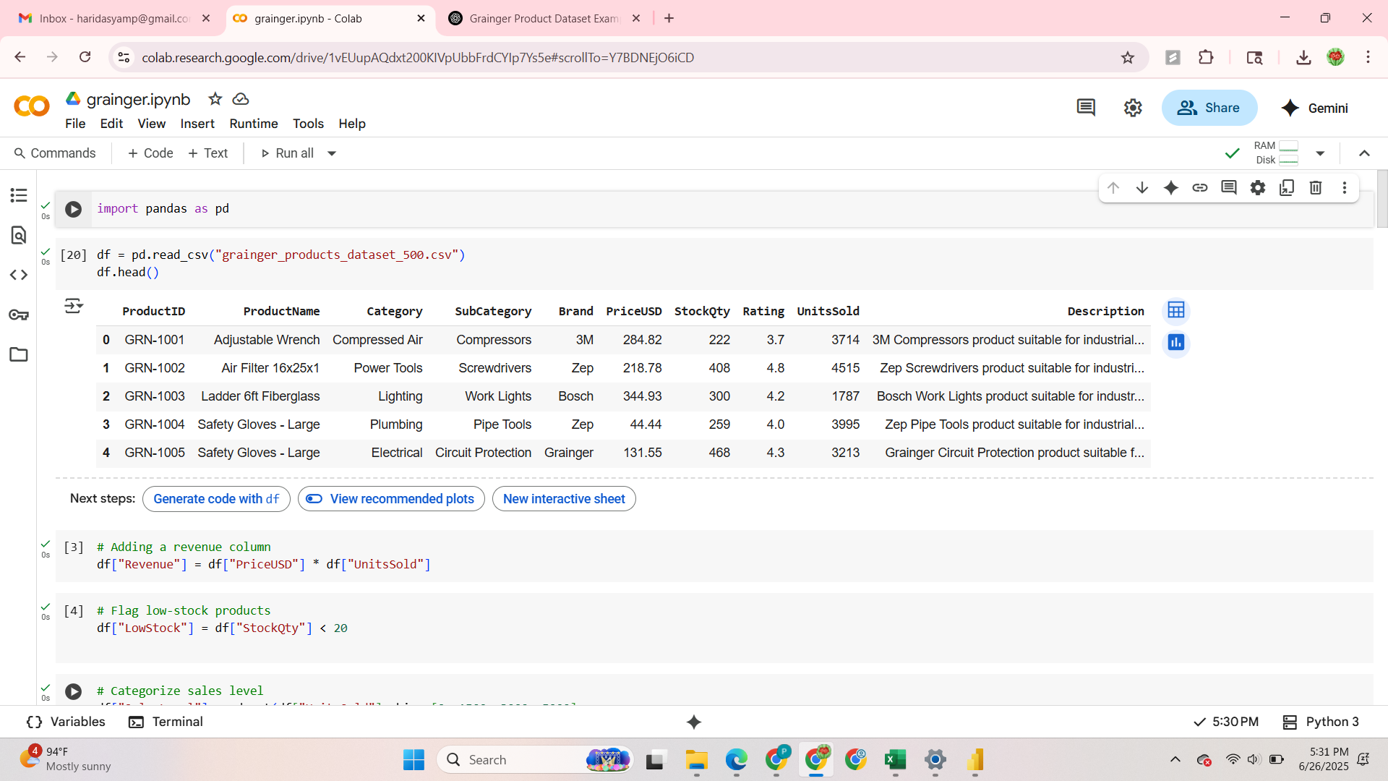
Fig 1: Created total revenue and low stock columns
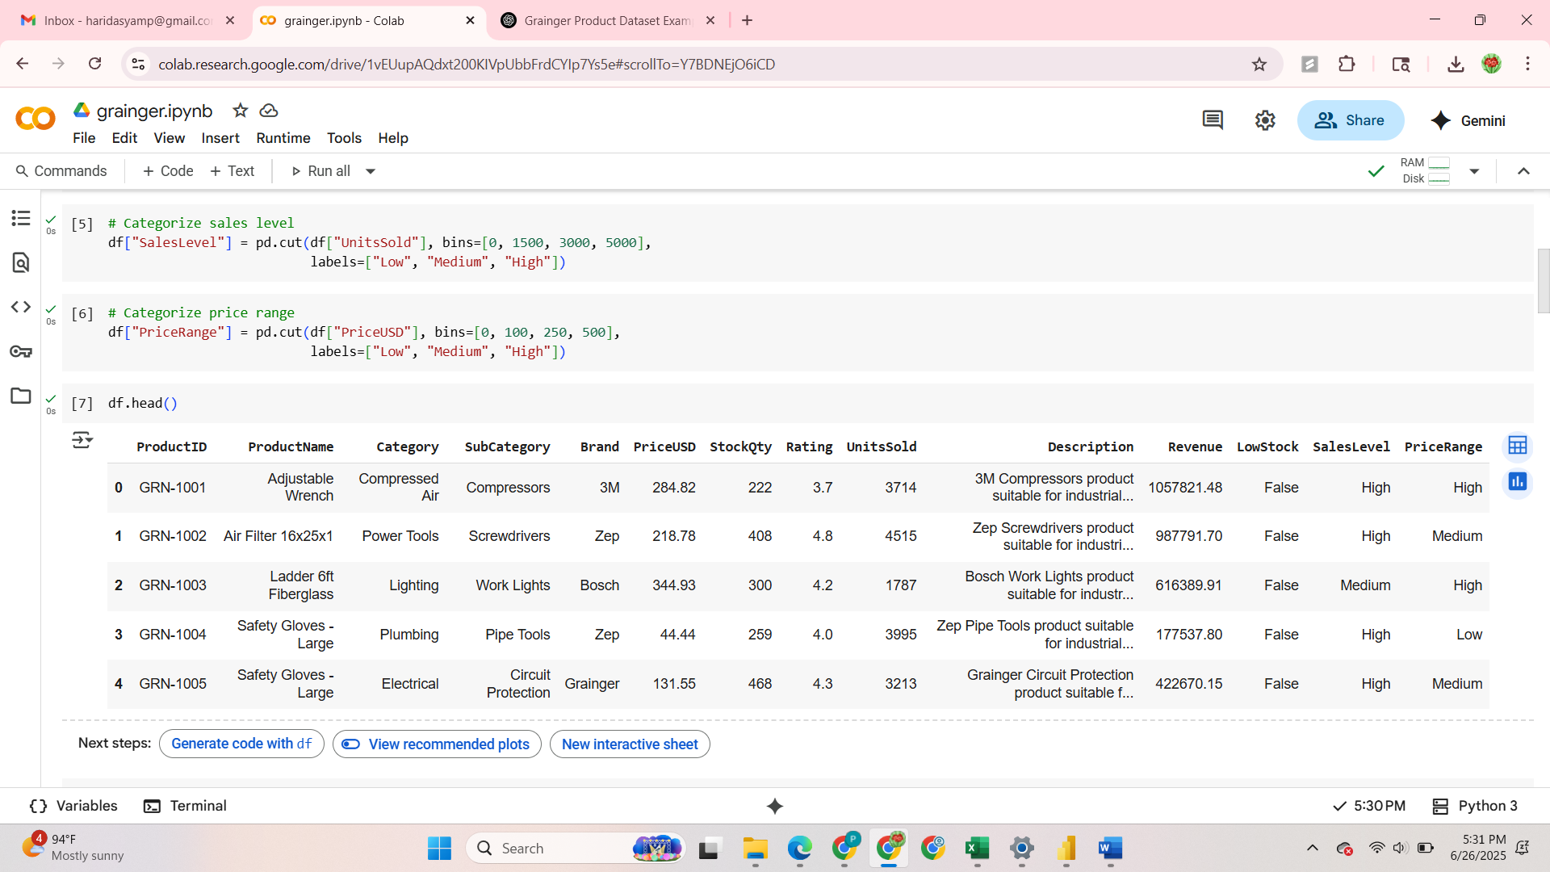
Fig 1.2: Grouped Sales level and Price range

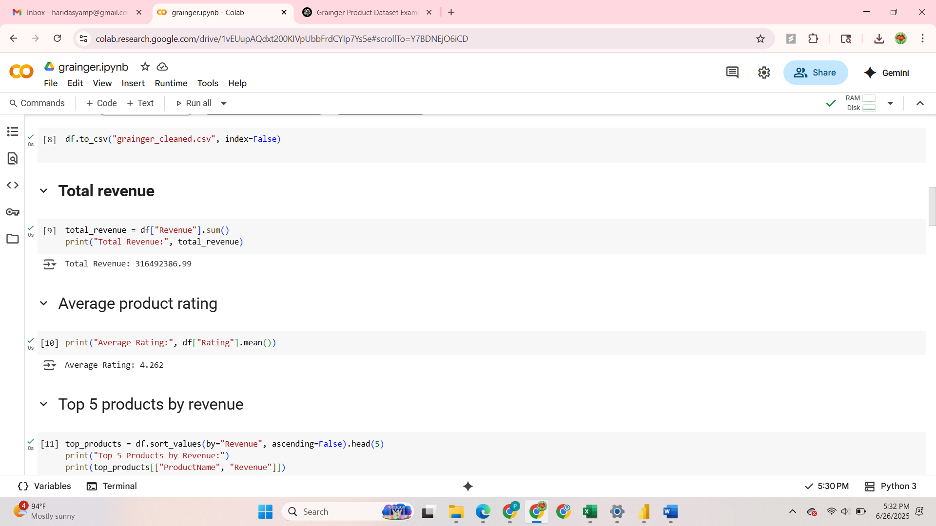
Fig1.2: Calculated Total Revenue and Average Product Rating
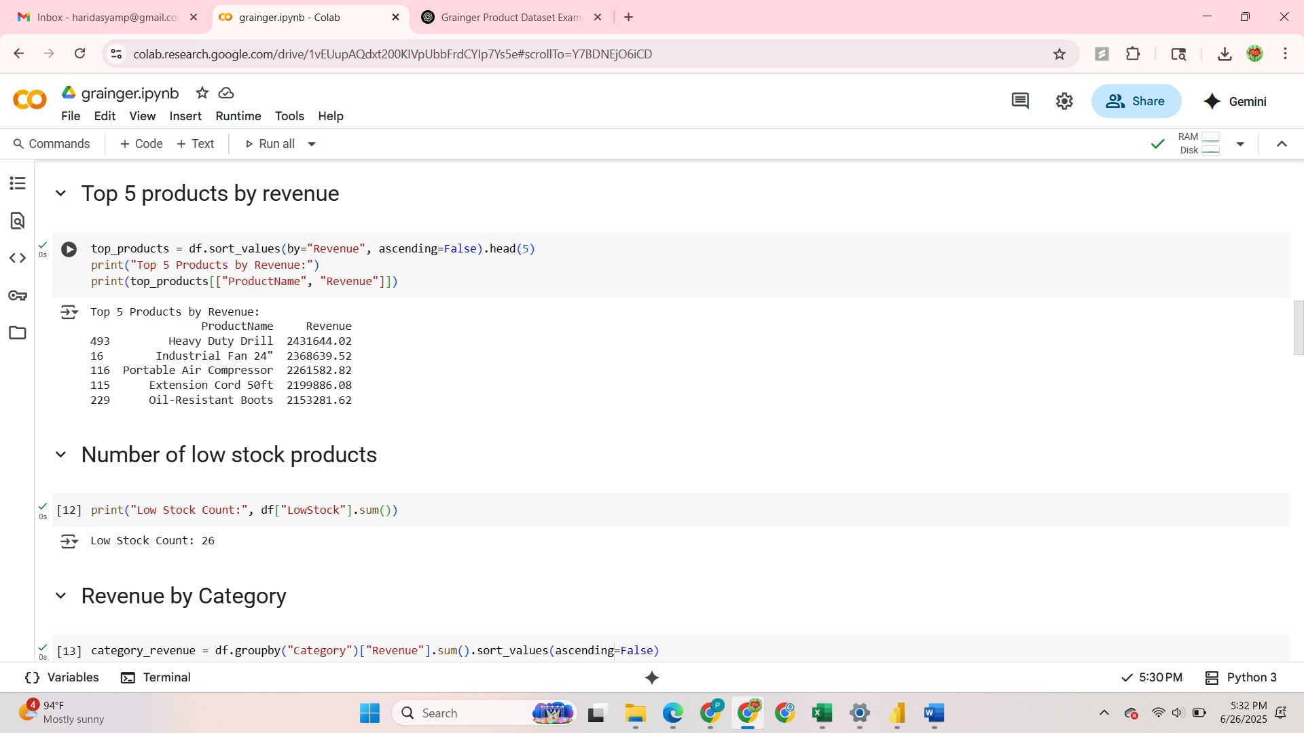
Fig 1.3: Calculated Top 5 Products by Revenue and number of low stock products

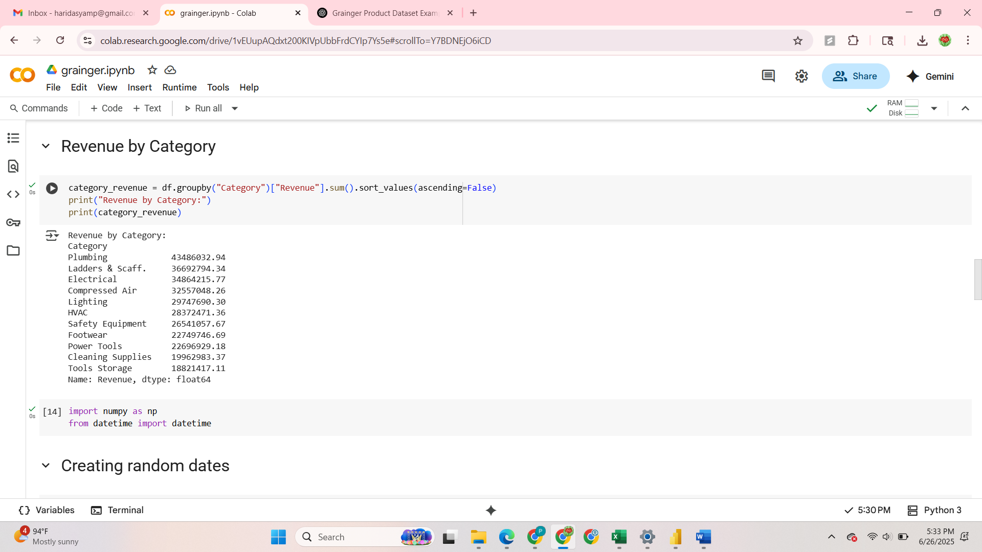
Fig 1.4: Grouped Revenue by Category
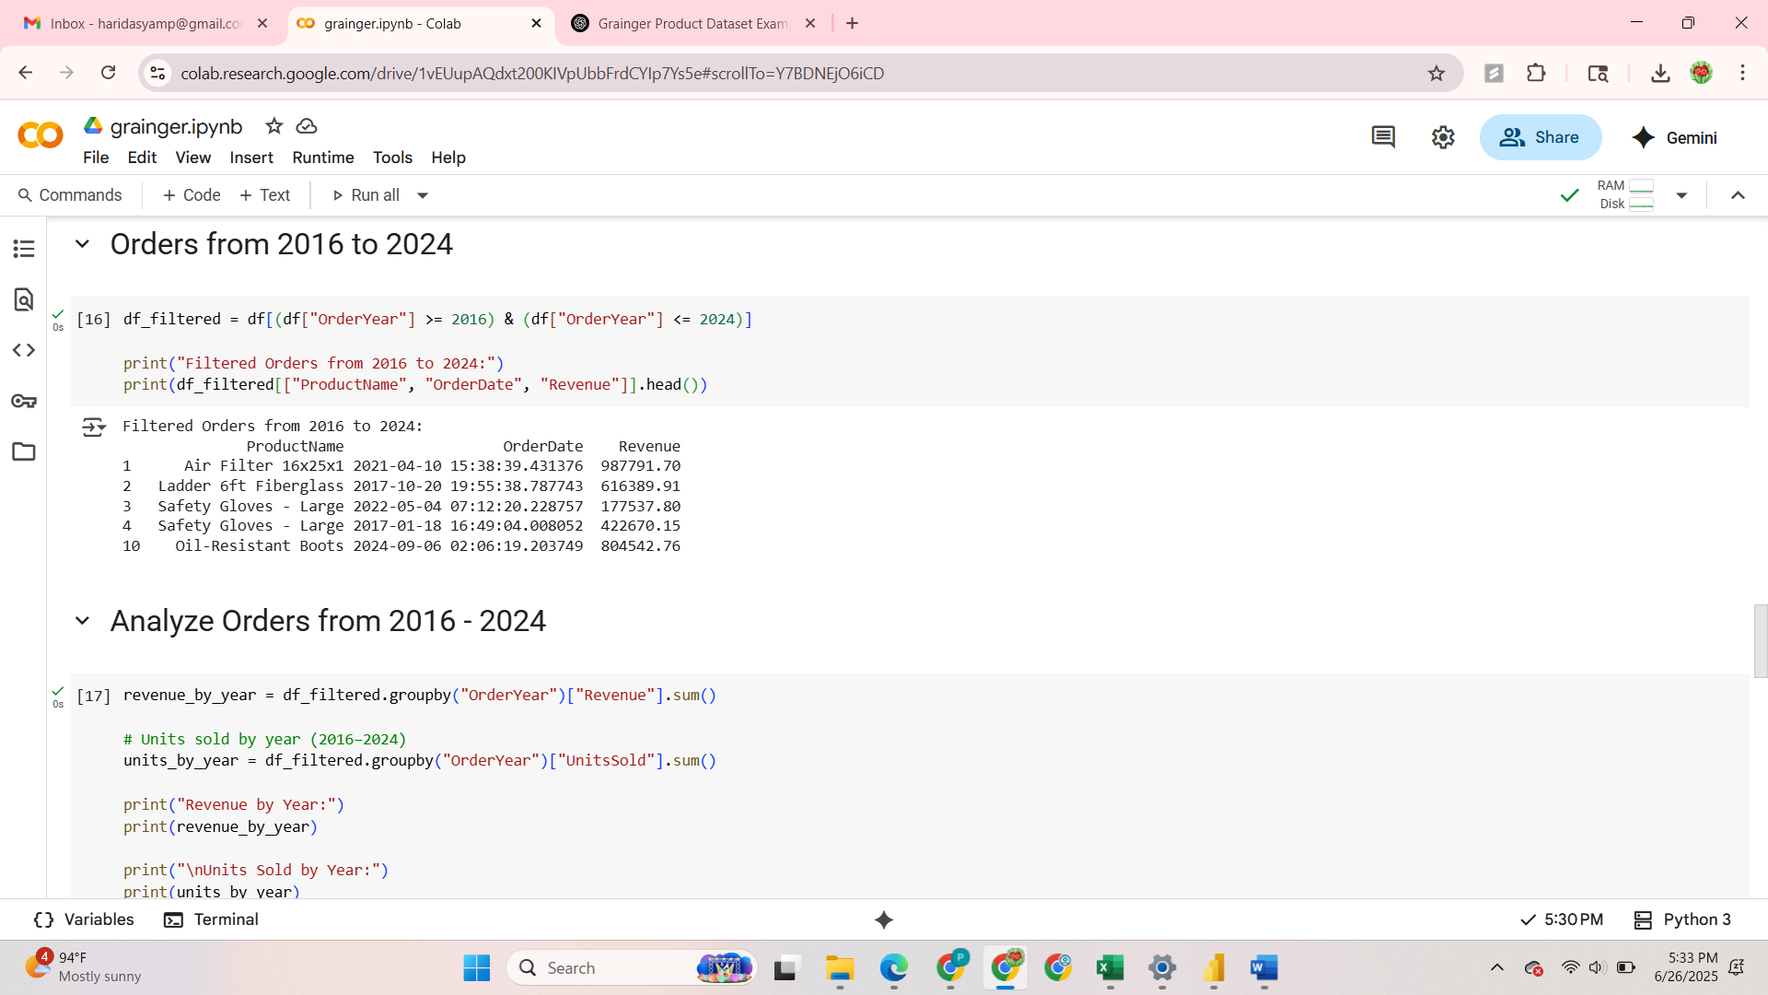
Fig: Filtered Orders from 2016-2024

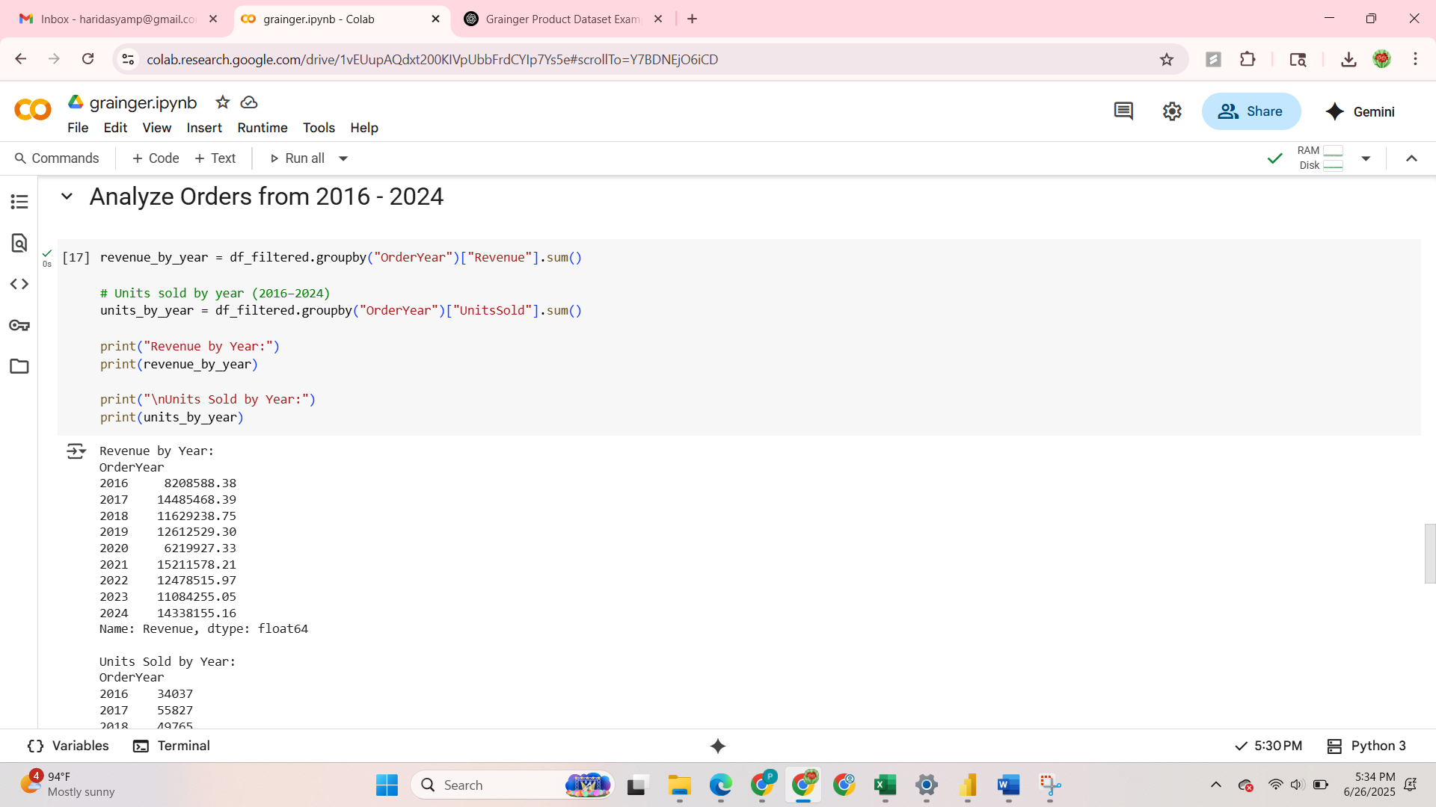
Fig 1.6: Analyzed the orders from 2016-2024

Dashboard Design
To highlight insights, I built a modern, dark-themed Power BI dashboard with clear visuals and filters. I focused on creating an executive-style layout with minimal clutter and strong contrast.
Key Dashboard Elements:
- KPI Cards
- Total Revenue
- Units Sold
- Avg Customer Rating
- % of Low Stock Products
- Top 10 Products by Revenue
A bar chart to spotlight high-performing items.
- Revenue Over Time
A line graph visualizing growth and seasonality across years.
- Product Table
A detailed table showing Category, Brand, Stock, Revenue, and Ratings, with formatting to highlight critical inventory.
- Slicers
Filters for Category, Brand, and OrderYear to make the dashboard interactive.
Design Decisions
I chose a midnight teal theme with soft neon KPIs and a flat, clean look. This helped make the visual insights stand out clearly even with a dense dataset. Layout was arranged to prioritize:
- Top-level KPIs
- Visual comparison of trends
- Drill-down capability via slicers
Insights
- Most revenue was concentrated in a few top-performing products.
- Several products were at risk of going out of stock.
- Revenue steadily increased from 2016–2023, with a slight dip in 2024.
- Customer ratings were generally above 4 stars, positively correlated with unit sales.
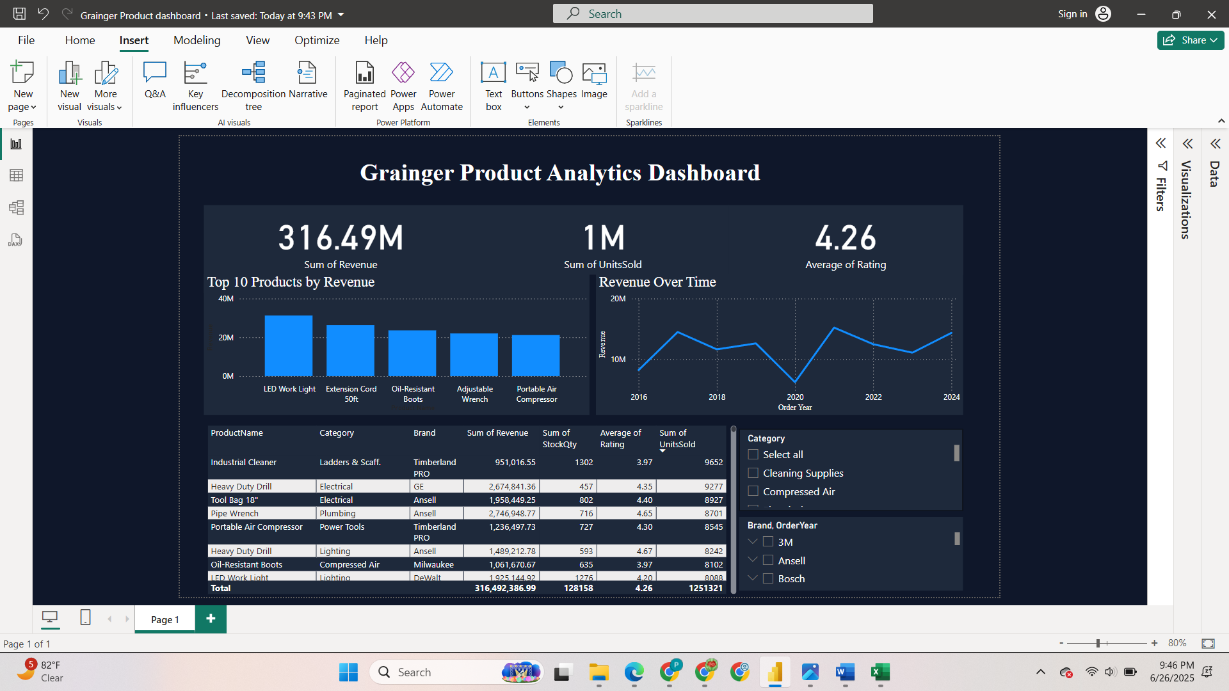
Fig: Power BI dashboard with KPI cards, a top products chart, revenue trend line, and product table

Outcome
This dashboard offers a one-stop overview for product performance, enabling teams to:
- Identify inventory risks
- Focus on top performers
- Analyze long-term trends by year
- Segment products by brand, category, or rating

